
UNIVERSITY OF HERTFORDSHIRE
School of Physics, Engineering and Computer Science
MSc Advanced Computer Science
7COM1039-0509 Advanced Computer Science Masters Project
18-07-2024

Interim Progress Report (IPR)

Resume Parser using Streamlit Framework

Name: Sanofer Sameena Riyas
Student ID: 22080596
Supervisor: Anish Saini

Table of Contents
1. Introduction and Overview 3
1.1 Background 3
1.2 Aim & Objectives 3
1.3 Research Question 4
1.4 Methodology 4
1.4.1 Design Hardware & Software 4
1.4.2 Dataset Domain 5
1.4.3 Investigation & Experiments 5
1.4.4 Experimental Design & Result 5
1.5 Ethical, Legal, Professional and Social issues 6
2. Progress to date 7
2.1 Progress 7
2.2 Problem Encounter 7
2.3 Literature Review 7
2.4 Technical Work 8
3. Planned word 9
3.1 Project Plan 9
3.2 Phases 9
3.2.1 Phase 1: Initial Research and Requirement Analysis 9
3.2.2 Phase 2: System Design and Architecture 9
3.2.3 Phase 3: Front-end Development 9
3.2.4 Phase 4: Back-end Development 9
3.2.5 Phase 5: Machine Learning Model Development 9
3.2.6 Phase 6: Testing and Validation 10
3.2.7 Phase 7: Final Reporting and Presentation 10
3.3 Gantt Chart 10
Bibliography 11
4. Appendices 12
4.1 Appendix 1: Hardware & Software Requirement 12
4.2 Appendix 2: Dataset 12
4.3 Appendix 3: NLP Techniques 13
4.4 Appendix 4: Algorithms of Machine Learning 13
4.5 Appendix 5: Experimental Design 13
4.6 Appendix 6: Web application interface 14
4.7 Appendix 7: Screenshots 15

Introduction and Overview
In recent times, the screening of resumes has become a major problem in recruitment especially for the fact that each job opening gets lots of applications. Traditional ways of reviewing resumes are time consuming and they have room for human errors and prejudices, hence inefficiencies in the hiring process. To tackle these challenges, automated resume parsing systems have become a very crucial tool that utilizes advanced NLP and ML to streamline and improve recruitment.
The focus of this project is development of an extensive resume parsing coupled with classification system utilizing such methods as NLP techniques, ML algorithms like K-Nearest Neighbors (KNN), Support Vector Machine (SVM) with Streamlit framework. The objective is to come up with an automatic, correct and easy-to-use solution which will make it simpler for HR professionals and recruiters to handle resumes more efficiently by enabling them to make better decisions on who they should hire.

Background

The importance of resume research in today's hiring process cannot be exaggerated. With the increase in job applications, manual resume reviews are becoming impractical for recruits, as they require time and are susceptible to human errors. Traditional resume analysis methods are largely based on rule-based systems and keyword matching, but provide basic automation, but are limited in the management of different formats and languages. A rule-based system often lacks the context and relevance of information, and can produce incomplete or incorrect analysis. On the other hand, manual analysis is labour intensive, subject to human errors and biases and invariable, making it more and more impractical as the number of applications increases. To address these problems, the proposed system is using natural language processing technologies (NLPs) (such as Named Entity Recognition(NER), Tokenization, Text classification, Regular Expression) and machine learning algorithms (such as K's closest neighbours and support vector machines (SVMs)) to automate and improve restart analysis and classification accuracy. The system aims to significantly improve the efficiency and effectiveness of recruitment processes and provide a solid solution to the traditional and manual limitations.

Aim & Objectives

Aim of the Project: Thus, the main goal of this project is to build an integrated resume parsing and classification system which uses machine learning and NLP techniques for more accurate resume screening in recruitment. The system aims at minimizing the amount of work done by the HR professionals while, at the same time, being equally effective in extracting and categorizing relevant information from resumes.

Objectives: To achieve this aim, the project has several specific objectives:
Data Collection and Preparation: Obtain an efficient resumes’ dataset from Kaggle focusing on a large number of resumes in the range from 300 to 500. Data should be cleaned adjusting formats and looking for errors the most important fields for analysis should be tagged into contact info, education, experience, skills.
Implementation of NLP Techniques: Use Named Entity Recognition NER, to distinguish the key entities’ by extracting from resumes. Tokenization, to break down the text into smaller and meaningful components.
Text Categorization, categorize different sections of the resumes more effectively. Phrase Match: using some pre-defined phrases to accurately fetch structured data in a formatted manner from unstructured text.
Development of Machine Learning Models: Train K Nearest Neighbors KNN and Support Vector Machine SVM models on the pre-processed dataset to cluster resumes based on job roles and accomplishment levels. Optimize the models to attain high accuracy.
System Integration and Interface Development: Develop a simple web interface using the example Streamlit library for end HR professionals to upload resumes and visualize parsed and classified data in real time. Make sure to integrate NLP and auto learning models into the Streamlit layer for easy processing and interaction.

Research Question
Research Question: How to mix Natural language processing algorithms (NLPs) with system getting to know algorithms (MLs) which include K-Nearest Neighbors (KNNs) and Support Vector Machines (SVMs) to offer efficient and accurate performance analysis and classification on inside the recruitment method?

Hypothesis: The integration of NLP and ML algorithms (KNN and SVM) in a resume parsing device will notably beautify the performance and accuracy of extracting key records and categorizing resumes into predefined businesses as compared to conventional guide techniques and fundamental keyword search systems. This improvement will bring about a more streamlined and powerful hiring technique, decreasing the effort and time required for guide opinions and minimizing human mistakes and bias.

Methodology

Design Hardware & Software
Hardware Requirement:  - Hard Disk: 500GB & above.  - RAM: 4GB & above.  - Processor: i5 & above  - OS: Windows 7/8/9/10 (64-bits)  NLP Techniques:  - Named Entity Recognition (NER)  - Tokenization  - Text Classification  - Regular Expression | Software Requirement:  - Programming Language: Python  - Tools: Visual Studio Code, Google Colab for model training.  - Database: SQL for storing parsed resume Data  - Framework: Streamlit for the web interface.  - Libraries and Tools details is shown in Appendix 1

Dataset Domain
Key Aspect of the Dataset:  Source: Kaggle resumes and manually collected resumes.  Volume: 300 to 500 resumes.  Content: Each resume includes the following:  - Contact Details: It will link name, phone, and email.  - Education: Fields, establishment, graduation years.  - Experience: Any name of a job, the organization, the period, and roles performed.  - Skills: Hard and soft skills. | Specific Questions Addressed in the Dataset:  Skill Matching: Comparison of the resumes with the skills that are obtained from those resumes matched with the skills mentioned in the predefined job descriptions.  Qualification Matching: A close check should be taken so as to guarantee that the qualifications mentioned match the job roles being classified.  A detail explanation of data set is shown in Appendix 2.

Investigation & Experiments
During the investigation phase, I was able to assess the current approaches in identifying methods of resume parsing and classification. The NLP techniques & ML are explained in Appendix 3, 4.
Literature Review:  Research Papers: Read the existing literature on the resume parsing and classification by using the machine learning approaches. These references involved using of NLP in resumes, comparing the effectiveness of KNN and SVM, and the problems faced with traditional parsing.  Industry Standards: Explored the tools and software present in the market about the operation, disadvantages, and reviews from the customer’s perspective. | Dataset Collection:  Kaggle: Decided to use Kaggle as the primary source of resume diversity because of the following reasons. The dataset consists of roughly about 300 to 500 resumes, and thus it has different formats, structures, and content.  Data Annotation: It involved manually tagging relevant information to do with contact details, education experience, and skills from the dataset. This step was very important in order to train up the machine learning models to the correct manner.
During the experimental phase, I developed and validated resume analysis and classification systems using the latest NLP, ML techniques. I began collecting 300 to 500 resumes from Kaggle and drafted manual annotations of essential details such as contacts, education, experience and skills. I use Named Entity Recognition (NER) for the analysis of entities, tokenization for the processing of texts and regular expressions for the extraction of patterns. I trained K-Nearest Neighbors (KNN) and Support Vector Machine (SVM) models for classification using Google Colab and trained models for optimal network-based GPU connectivity training with toolbars. Then I put these models into Streamlit (file) apps, allowing HR professionals to upload data and calculate the best compensation as an error arbitration.

Experimental Design & Result
- Dataset Preparation: Sourced and annotated a dataset of 300 to 500 resumes from Kaggle.
- Using NLP: We conducted retrieval of candidate resumes and applications, tokenisation, text classification.
- Model Training: I use Google Colab to train the KNN and SVM models and achieve an accuracy, with a lot of hyperparameter tuning and cross validation. (is shown in Appendix 5)
- Interface Development: The Streamlit application that interfaces with the development (taking in the resume by asking for it as input, and then uploading the visualisation when mapping to the models in the backend), was made. (is described in Appendix 6).
- Validation & Test: Had thorough testing to confirm model’s functionality and extend our interface; incrementally improved based on feedback from data and test results.
System Architecture:
A detailed architecture of resume parser is shown in Figure.2 in Appendix 5
- HR module: Tools to manage, organize and filter job listings effectively.
- User module: Interface to upload job listings and get information on job titles.
Future Improvements:
- Advanced AI Integration: Add advanced AI technology to deepen career searches.
- Job Proposal: Create personalized job proposal based on job review.
- Extension of data sources: Integrate professional network data and open storage to expand data sets.
Result:
Screenshots illustrating tokenization and dataset cleaning, can be found in Appendix 7.
Model Accuracy: The achieved accuracies for both the KNN and the SVM models for the training and the validation. Higher accuracy values indicate that the models are very robust in classifying resumes into their original categories annotated in the dataset.

Ethical, Legal, Professional and Social issues
Several ethical, legal, professional and social issues arise from creating and applying an automated resume parsing system that is based on NLP and ML algorithms. Ethically, this means that when using these algorithms, one has to take care not to be discriminative as this may create more inequalities in the employment sector. Legally, any such system must comply with data protection regulations like GDPR or CCPA in order to ensure secure handling of candidates’ personal information and their privacy rights. Professionally, the parsing system should be accurate and reliable because mistakes can lead to mis tagged candidates thereby affecting their career opportunities negatively. Additionally, it is crucial for guidance regarding how it functions and makes choices so that there are no doubts among its users. On a societal plane the process is aimed at increasing efficiency but may diminish human input in recruitment which may dehumanize hiring process having consequences on candidate experiences. Thus, balancing technological advancements with these apprehensions will guarantee a fair, transparent, and accountable program for all stakeholders involved.

Progress to date

Progress
We have made great achievements on the development of resume automatic parsing and classification system. First, after a deep dive research of Kaggle I have found 3 datasets (300,500) resumes in which all are annotated to tag key-information such as contacts, education, experience, skills etc. So, all of NER tokenisation and text classification have been done. then I trained machine learning models such as K-Nearest Neighbors (KNN) and Support Vector Machine (SVM) using Google Collab program and got a high accuracy at the same time based on Streamlit I made a friendly user interface where HR personnel can upload resumes and then parsing/classification results will be seen clearly.

Problem Encounter
Description: Resumes are many in structure and form hence a challenge to seek to harmonize the data for scanning. This can lead to errors in extracting important information including; the contact information, education, experience and skills.
Problem 1: Inconsistency of the data
Solution: For text processing implements Standardizing format, error correcting, remove irrelevant contents. On other hand entity extraction using NER to normalize extracted features from resumes. It’s achieved by Spacy NER model that improves the process of data extraction and the efficiency of which directly depends on the NLP model chosen (Chavare, 2023).
Problem 2: Classification Accuracy
Solution: Improved the classification algorithms based on the changes of hyperparameters and implementation of cross-validation methods. Furthermore, more training data was incorporated into the models in an attempt to increase the models’ resistance to noise.

Literature Review
Resume parsing has come a long way and the use of natural language processing and manginess learning has enhanced the parsing and categorizing of the information. A method uses the Spacy NER model that improves the process of data extraction and the efficiency of which directly depends on the NLP model chosen (Chavare, 2023). One paper focuses on BERT for the sentence pair classification with 100% accuracy for the classification of LinkedIn resumes and 73% for the candidate suitability while the models’ performance declined in other formats (Shah, 2019). This shows that it is possible to use BERT to set up a starting point for generating the rank of order of how suitable a candidate.
Besides, the high efficiency of resume parsing has been achieved by Neural Networks and CRF where CNN different segment classification is used while Bidirectional LSTM-CNN with CRF is using for sequence labelling. Its strength is on the segmentation and entity extraction but for large dataset it may turn to be costly in terms of computation (Ayishathahira, 2018). Another noticeable approach applies NLP and deep learning for NER and obtains an identification accuracy of 93% when it is distinct resume formats (Thangaramya, 2024).
The e-recruitment framework uses text block classification, NER, and ontology to extract correct information but this process is time taking because require large annotated data set (Sajid, 2022). There is a basic approach that require using keyword matching and clustering, while it is easy to use, it is quite rigid in terms of different formats of resumes (Satyaki Sanyal, 2017). Consequently, through the processes of multi-label classification, the group of neural network models, including BPNN, CNN, BiLSTM, and CRNN, displayed a high level of accuracy in analyzing the texts with the notes that the higher accuracy depends on the specifics of the selected model. The combination of NLP with ATS results in resume parsing and ranking hence giving real-time analysis of the recruitment process, but this integration is done with existing ATS systems (Manobharathi.V, 2023). The study by (Madhumita Srivastava, 2023)on ‘‘multipartite job domain BERT-based Named Entity Recognition’’ supports the essence of the quantity and quality of data annotated for proper information extraction. Furthermore, when used along with keyword and pattern matching that is achieved by employing Regex, accuracy of NER is high irrespective of format of resume (Sougandh, 2023)
It is equally important to note that the multi-level classification technique in the resume segmentation significantly reduces employers’ time but needs a large training dataset (Gunaseelan, 2020) The process of candidate ranking is based on Machine Learning, and in particular, the “Predictive Human Resource Candidate Ranking System” is used for that; Experience and skills are main criteria for candidate selection, but it requires much development time (Koyande, 2020). Another approach is for prediction of the job domain by applying NER on the basis of skill sets, which yields acceptable accuracy, though the result strongly depends on input data (Mittal, 2020).
The techniques of text conversion and similarity comparison assist in the consideration of CVs and the matching with job descriptions, but they encounter issues with different types of resume presentations (Chan, 2022) Online Resume Parsing Resumes into jobs employing Text analysis and sentiment analysis help with an efficient recruitment process but incorporate bias into the assessment of the sentiment (Chandola, 2015).
Last, in my project “Resume Parser using Streamlit Framework,” I use K-Nearest Neighbors (KNN) and Support Vector Machine (SVM) for classification and prediction to increase performance after applying data preprocesses and features extraction.

Technical Work
The technical work completed so far has focused on the essential aspects of data preparation, the implementation of NLP techniques, and the ongoing process of model training and implementation.
Data Preparation:
- Data Collection: Collected 400 resumes from Kaggle and manual.
- Data Cleaning: Standardized format, error correction, and removed irrelevant information. (shown in Appendix 7)
- Data Annotation: Labelled key section such as skills, education history.
NLP Implementation: (Appendix 3)
- Tokenization: Split text into Tokens (example of tokenization can be found on Figure 3).
- Named Entity Recognition (NER): Identified entities such us names, education, skills, date.
- Text Classification: Categorized text into predefined sections like skill and education.
Model Training: (Ongoing)
- Training Models: Currently training KNN and SVM models on the pre-processed and annotated dataset.
- Hyperparameter Turing: Optimizing model parameters to achieve high accuracy.

Planned word

Project Plan
The plan of the project defines the most important activities to implement the automated resume parser with the help of Streamlit. These activities can be grouped into phases and each phase has core set of goal and a set of products that must be produced. This has the starting phase of the project, pre-analysis and design phase, implementation and integration phase, testing and validation phase, and the final reporting stage. The plan helps avoid a random pattern of organizing the procedures of constructing a functional and efficient resume analysis system.

Phases

Phase 1: Initial Research and Requirement Analysis
This phase, lasting 1.5 weeks will entail a literature review on resume parsing and the associated machine learning methods. From the current systems, the team will determine their shortcomings and get the requirements from the HR professionals, and anyone seeking a job. The artifacts developed for this phase are a literature review document and requirement specification document. It will help in making sure that all required literature review has been done embracing all the related studies and that a proper requirement specification has been developed in the best pleasure of the stakeholders.

Phase 2: System Design and Architecture
Spanning 1.5 weeks of this phase, the researchers will be involved in designing the general system architecture of the solution, and develop modules for the HR and users. The descriptions of the modules and the interaction diagrams will be developed: This raises the following deliverables, a system architecture diagram and a module description document. The design will be tested through peer reviews and feedback collected from the stakeholders so as to prove its efficiency and utility towards the achievement of the laid down project objectives and goals.

Phase 3: Front-end Development
For the next 2 weeks the State-Space approaches, as well as Front-end User Interface, will be developed with the help of the Streamlit. The options for uploading the resume and parsed information about a candidate will be added. The primary output, which will be produced by the end of this phase, is a functional front-end model.

Phase 4: Back-end Development
This phase which will take 3 weeks will incorporate the creation of back-end works for the resume parsing and data storage. To screen resumes, information extraction methods of NLP will be used to determine essential information. Some examples of deliverables will be the source code of the Web back-end and the specification of the required database structure. Quality assessment would be done during code reviews and during integration tests to check on the back end functionality and the integrity of the data.

Phase 5: Machine Learning Model Development
There, in this 3 weeks, KNN and SVM models of resume classification will be trained and tuned. These models will be linked with the backend system. The tangible outputs will therefore include the trained machine learning models for early warning system and a model evaluation report. The performance model will be assessed by indicators such as accuracy, specific degrees of precision, and degrees of recall, and changes will be made based on the assessment.

Phase 6: Testing and Validation
This 2-week phase will refer to the period where all the units, sub-systems and the total system will undergo detailed unit, integration and system testing. All the given entities of the system will be checked for compliance with initial requirements and preliminary feedback. Some expected end products are test cases, test report, and a validation report. Quality evaluation will make certain that all test pass and the system is as per specific requirement as well as expectation of the users.

Phase 7: Final Reporting and Presentation
The last stage of this process is and takes 1. 5 weeks will entail writing the final project report that will include the description of all the phases and outcomes. A presentation will be developed in order to illustrate the system. The tangible deliverables of this research will be the final report in document format and power point slides and a demonstration script. Assessment will include the following activities; review of the report and presentation in order to determine the coherence and logical presentation of the data, and presentation rehearsals in order to improve the demonstration.

Gantt Chart
Phase | Duration | Tasks
Phase 1 | 1.5 Weeks | Literature review, requirement analysis, stakeholder consultation
Phase 2 | 1.5 Weeks | System design, module descriptions, interaction diagrams
Phase 3 | 2 Weeks | Front-end development using Streamlit, UI implementation
Phase 4 | 3 Weeks | Back-end development, NLP integration, data storage
Phase 5 | 3 Weeks | Machine learning model training, integration, evaluation
Phase 6 | 2 Weeks | System testing, validation against requirements
Phase 7 | 1.5 Weeks | Final report writing, presentation preparation, mock demonstrations

Table 1 Overview of Project Phases, Durations, and Key Tasks
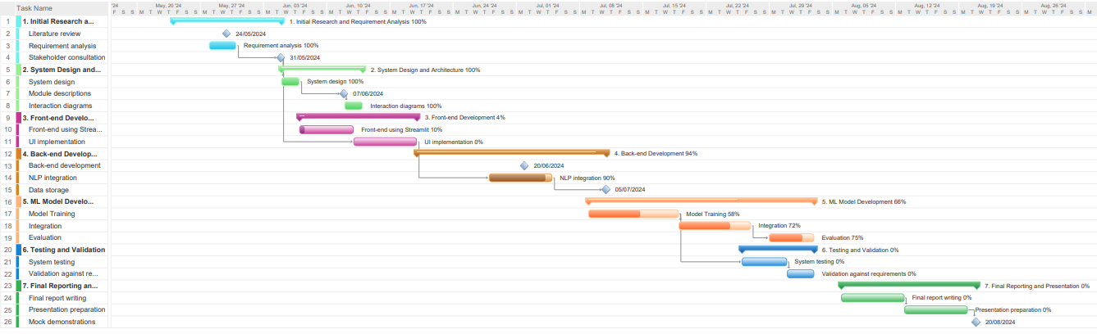
Figure 1 Overall Project Gantt Chart

Bibliography

Ayishathahira, C. H., 2018. Combination of Neural Networks and Conditional Random Fields for Efficient Resume Parsing. s.l., IEEE.
Bhor S., G. V., 2021. Resume parser using natural language processing techniques. s.l., academia.edu.
Chandola, D., 2015. ONLINE RESUME PARSING SYSTEM USING TEXT ANALYTICS. s.l., JMDET.
Chan, J. H., 2022. Resume Parser with Natural Language Processing. s.l., IEEE.
Chavare, D. S., 2023. Resume Parsing using Natural Language Processing. s.l., academia.edu.
Gunaseelan, B., 2020. Automatic Extraction of Segments from Resumes using Machine Learning. s.l., IEEE.
Koyande, B. A., 2020. Predictive Human Resource Candidate Ranking System. s.l., IJRESM.
Krishnamoorthy S., L. J., 2022. Resume parsing based on multi-label classification using neural network models. s.l., IEEE.
Madhumita Srivastava, P. G., 2023. Resume Parsing Across Multiple Job Domains Using a BERT-Based NER Model. s.l., IEEE.
Manobharathi.V, 2023. Automated Resume Parsing and Ranking System through Natural Language Processing. s.l., IEEE.
Mittal, V., 2020. Resume parsing and job domain prediction. s.l., Taylor&Francis.
Sajid, H., 2022. Resume Parsing Framework for E-recruitment. s.l., IEEE.
Satheesh.K, 2020. Resume ranking based on job description using SpaCy NER model. s.l., academia.edu.
Satyaki Sanyal, S. H., 2017. Resume Parser with Natural Language Processing. s.l., Research Gate.
Shah, R. R., 2019. End-to-End Resume Parsing and Finding Candidates for a Job Description using BERT. s.l., Corell Universiry.
Sougandh, T. G., 2023. Automated Resume Parsing: A Natural Language Processing Approach. s.l., IEEE.
Tahir.K, 2016. Intelligent hiring with resume parser and ranking using NLP and ML. s.l., rakeshgunduka.me.
Thangaramya, K., 2024. Automated Resume Parsing and Ranking using Natural Language Processing. s.l., IEEE.

Appendices

Appendix 1: Hardware & Software Requirement
- Hardware: Intel Core i5 and above Processor, 4GB RAM and 5GB Hard disc drive.
- Software: Python Language, Streamlit Framework, SQL Database management system, Visual Studio Code for integrated development environment.
- Libraries and tools:
        - NLTK (Natural Language Toolkit): For basic NLP tasks such as tokenization
        - SpaCy: For advanced NLP tasks, particularly Named Entity Recognition (NER)
        - Scikit-Learn: For machine learning models and evaluation metrics.
        - Pandas: For data manipulation and analysis.
        - Google Colab: For model training.

Appendix 2: Dataset

Data Collection:
- Source: The datasets are harvested from Kaggle, a popular machine learning dataset source website, where people publish many resume datasets. Kaggle offers an active archive of resume datasets from various authors, so there is much diversity in the format and structure of the resumes.
- Volume: The dataset has around 300 to 500 resumes which should be enough to train and test the models with good coverage of variations in resume content and formatting
Data Content:
- Extracted Fields: The dataset contains resumes with several fields like contact, education, experience, projects, skills etc. These fields will help train our model to extract similar fields from new resumes.
- Diversity: Resumes are obtained from different domains and different roles/jobs which in turn helps to have the model learn various terminologies and get a good understanding of all kinds of resumes. It’s necessary to have a good spread of the data across different domains/roles to build a generic model.
Data Preparation:
- Cleaning: A cleaning process is undertaken on the dataset so as to eliminate any irrelevant details, inconsistencies or mistakes in it. Therefore at this point we have accurate and standardized data that will be fed into the model.
- Formatting: Standardizing the layout of resumes in the dataset is imperative to guarantee the model's ability to generalize effectively. This process involves standardizing text formats, rectifying typographical errors, and ensuring consistency in the representation of fields
Data Annotation:
- Tagging: Each resume in the collection is tagged with the pertinent job role and skill levels. This tagged data is vital for supervised learning, permitting the model to learn the correspondence between resume contents and the intended results.
- NER and Classification: Through NLP techniques, named entities like names, organizations, dates, and unique skills are annotated. This annotation aids the model in proficiently identifying and classifying these entities in new resumes.
Dataset Splitting:
- Training and Testing: The dataset is divided into training and testing subsets. Generally, 70-80% of the data is allocated for model training, with the remaining 20-30% reserved for testing. This division ensures the model's evaluation on novel data, offering an accurate gauge of its performance.
- Cross-Validation: To augment the reliability of the model's assessment, cross-validation methods are utilized. This entails partitioning the dataset into multiple sections and training/testing the model on various combinations of these sections to ensure robustness and consistency

Appendix 3: NLP Techniques
- Named Entity Recognition (NER): applied NER to extract and classify entities in resumes: names, organizations, dates, locations, etc. SpaCy and NLTK were utilized for this purpose.
- Tokenization: Tokenisation to parse text content into single words or tokens. This is a preprocessing step to allow easier access, search and manipulation of text data.
- Text Classification: Used TF-IDF and Word2Vec embeddings on part-of-speech tagged biomedical texts to train a text classification model to separate resume sections (college education and work experience).
- Regular Expressions: Made use of regular expressions to find matches such as telephone numbers, email addresses, and dates.

Appendix 4: Algorithms of Machine Learning
- K-Nearest Neighbours (KNN): A KNN trained to predict resume labels (job role, skill level, etc), using hyperparameter-tuning through grid search.
- Support Vector Machine (SVM): It casts the above described problem as a linear model: using the hyperplane created from all the data available, sort the unseen inputs into positive or negative classes. SVM is very high-dimensional to be robustness against overfitting.

Appendix 5: Experimental Design
Model Training & Validation:
- Google Colab: Trained the machine learning models on Google Colab as it provided GPU acceleration and was fast for training and experimentation.
- Validation: Destructive splitting of the dataset into a separate test set and training set (say, 80-20 split), which released the test set (holdout sample) for radical validation of all models.
System Architecture:
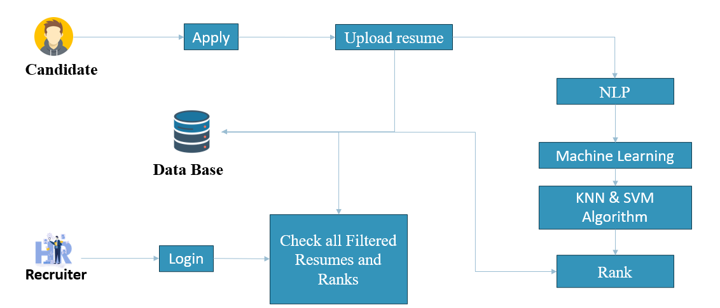
Figure 2 System Architecture
Accuracy & Results:
- This model achieved a high accuracy, both for training and for validation. The chosen algorithm seemed to be effective, and, so far, the preprocessing did a good job separating the spectrograms.

Accuracy = $\frac{Number of correct Predictions}{Total Number of Predictions}$

- Categorisations: Used visualisations to create intuitive ways of displaying the clustering results and the performance metrics of the different models and integrated the models and results into a Streamlit web app that would be easier to understand for onsite HR personnel
Streamlit Integration:
- We used Streamlit libraries to be able to upload resumes, read and parse the information, and then classify it, without the need for domain knowledge nor specific coding. web-interface-Upload be able to upload resumes, read and parse the information to display it. web-interface-Classification be able to upload resumes, and finally display both the parsed information and the classification result. All the models were trained and able to be used in a Streamlit application, in order to process the information from the resumes in real time and display it.

Appendix 6: Web application interface
- Description of the user interface with some screenshots of its development through Streamlit.
- It has a function for uploading CVs and displaying parsed information with classified results.

Appendix 7: Screenshots
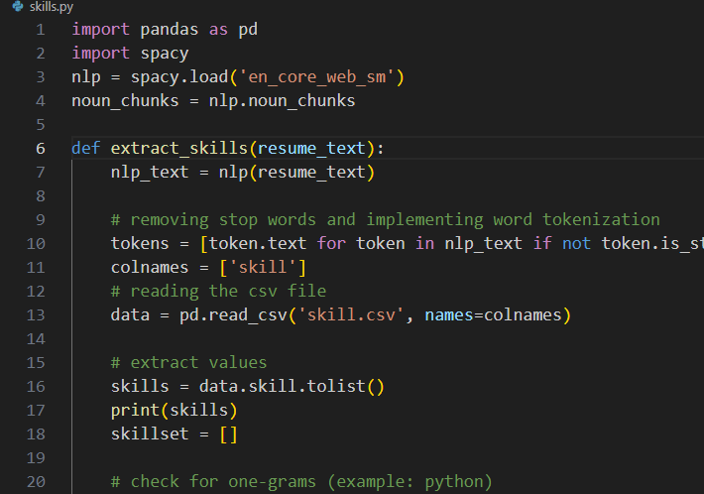
Figure 3 Tokenization
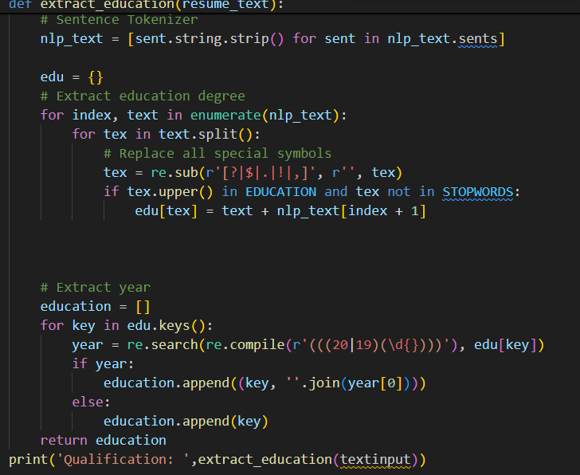
Figure 4 Qualification

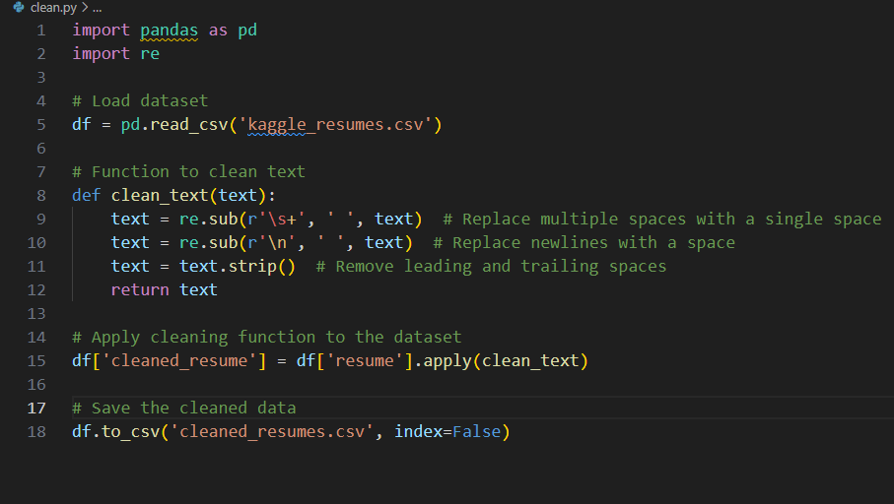
Figure 5 Cleaning dataset

